**Project Report Template**

INTRODUCTION:

* 1. Overview

An application tracing system (ATS) is software for the recuiters and employers to track candidates throughout the recruiting and hiring process. Every organization is unique but each one thrives on attracting hiring maximizing top talent many business face major challenge at some point in the hiring or onboarding process.

2.PROBLEM DEFINITION & DESIGN THINKING

2.1 EMAPTHY MAP

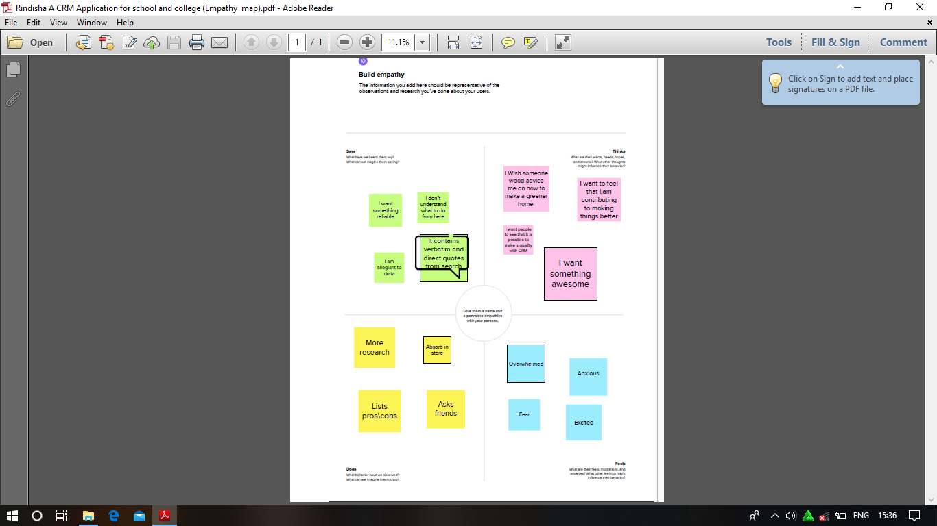

2.2 IDEATION &BRAIN STORMING MAP

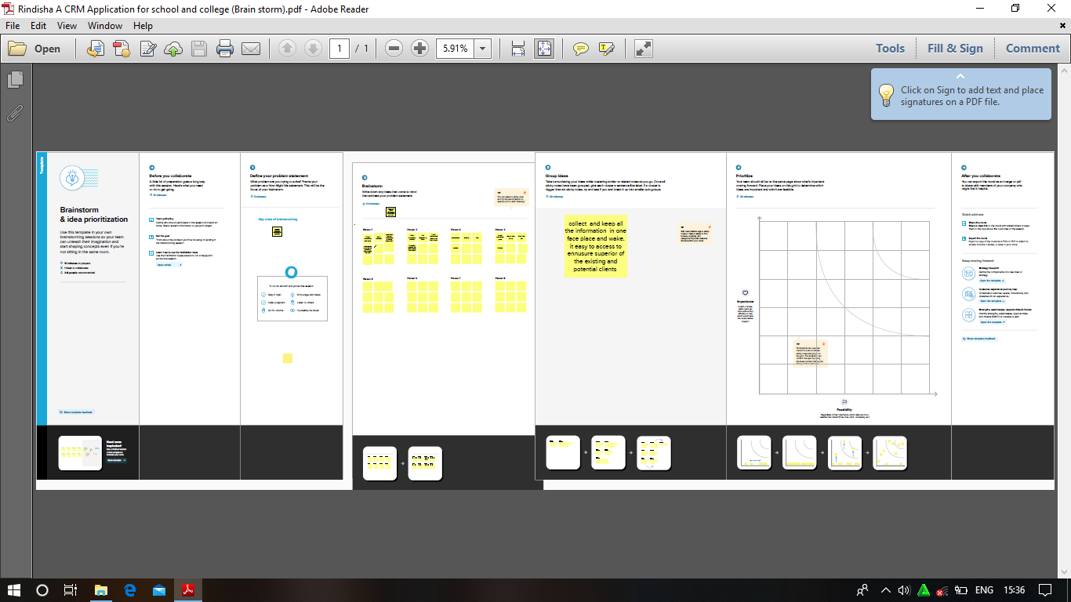

3.RESULT

3.1 Data Model

|  |  |
| --- | --- |
| Object Name | Fields In The Object |
| Obj 1: | |  |  | | --- | --- | | Fields Label | Data Type | | Look up field | Text Area | |  |  | |  |  | |
| Obj 2: | |  |  | | --- | --- | | Fields Label | Data Type | | Field name |  | |  |  | |  |  | |

3.2 Activity & Screen shot

Milestone 1:

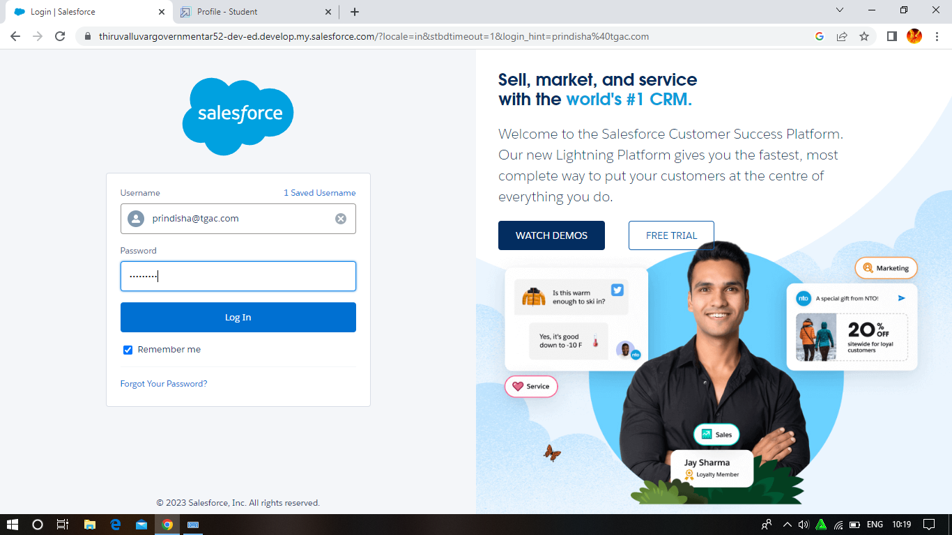

Milestone 2: Object

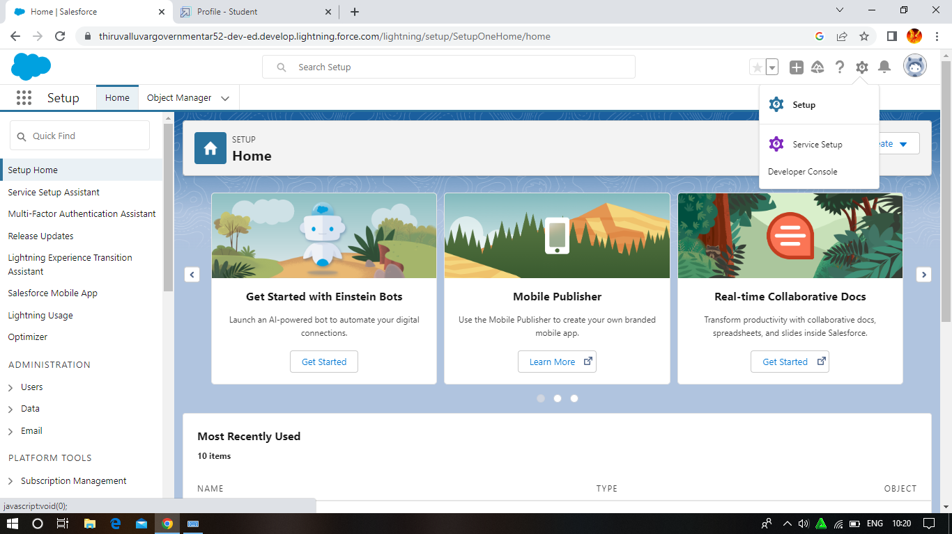

Milestone 3:Lighting App

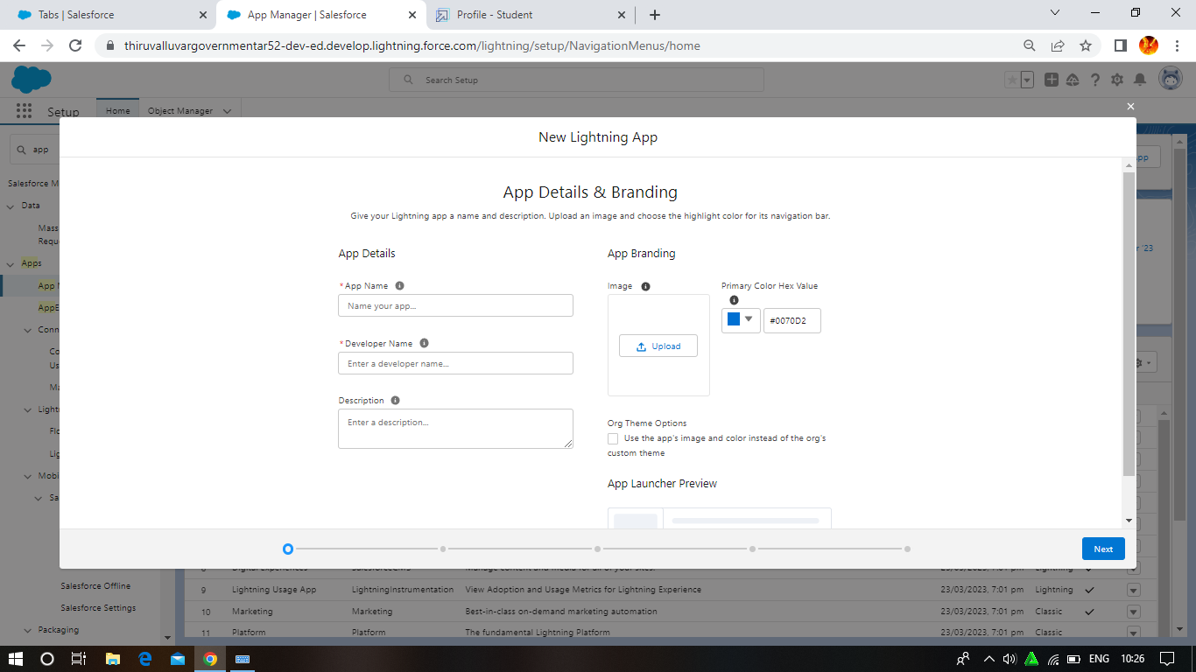

Milestone 4: Fields And Relationship

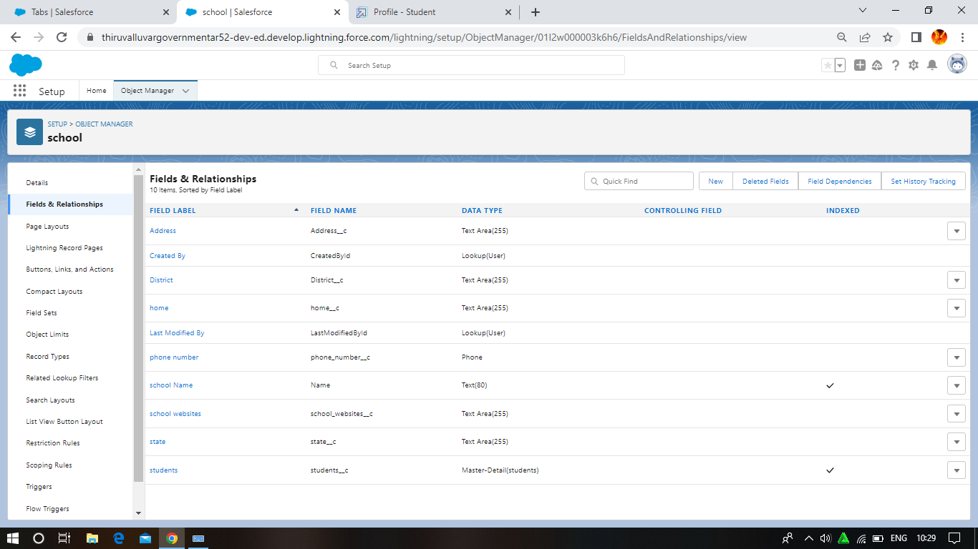

Milestone 5 : Profile

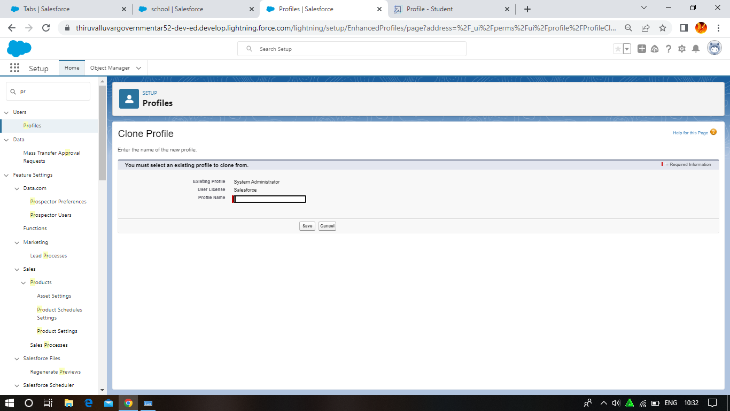

Milestone 6: Users

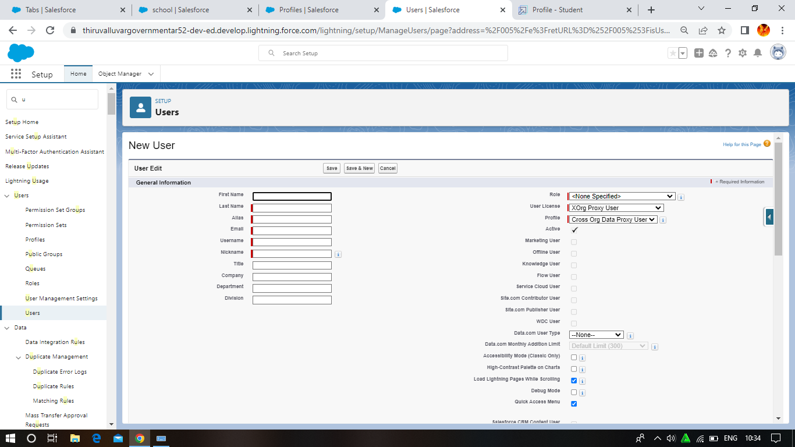

Milestone 7: 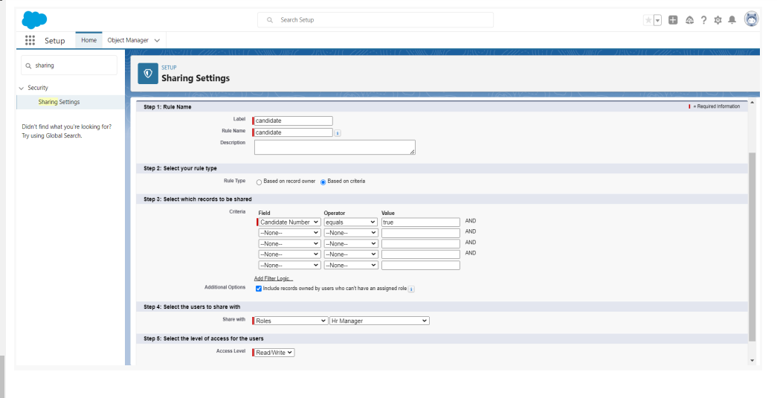

Milestone 8: 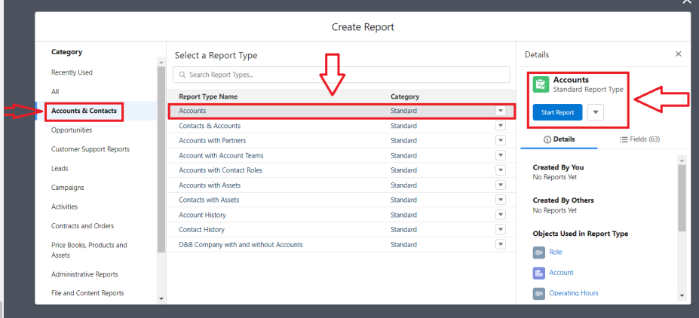

4. Trailhead Profile Public URL

Team lead - https://trailblazer.me/id/vyogeshwaranphytm

Team Member 1-https://trailblazer.me/id/tamtm1

5. ADVANTAGES & DISADVANTAGE

Advantage

Reduce time spent on admin tasks. ATS software allows you to automate various tasks of the hiring process that can save you a lot of time and free up your recruiting personal for the for other high-value tasks. Posting to multiple job boards, tracking candidate applications, notifing candidate individually, and scheduling interview feedback can all be automated.

Disadvantage

Communications can be less personalised. When automating responses to candidates, your messaging will be less personalised and can come off as robotic.

6. APPLICATION

An application tracking system (ATS) is software that manages the recruiting and hiring process, including job postings and applications. It organizes information about job seekers and makes it searchable. As its name implies, an ATS tracks candidates through the hiring process.

7. CONCLUSION

Project management helps to detail what tasks will be accomplished, who will be involved in completing the tasks, and when tasks should start and finish.

8. FUTURE SCOPE

A Scope an application tracking system (ATS) is software for recruiters and employers to track candidates throughout the recruiting and hiring process.